**ON CAMPUS MENTAL HEALTH SUPPORT SERVICES**

**ABSTRACT**

On-campus mental support services are an essential resource for college students who may be struggling with a variety of mental health issues. These services can range from counselling and therapy sessions to support groups and crisis intervention. The goal of these services is to provide students with a safe and supportive environment where they can help manage their mental health and navigate the challenges of college es of college life. Research has shown that students who utilize on-campus mental support services are more likely to persist in their academic programs, have better academic outcomes, and experience a higher overall quality of life. These services are often staffed by licensed professionals who have experience working with young adults and are trained to address a range of mental health concerns, including anxiety, depression, trauma, and substance abuse. While on-campus mental support services can be a valuable resource for students, there are often barriers to accessing these services. These may include stigma around mental health issues, lack of awareness about available resources, and limited availability of services during peak demand periods. To address these challenges, colleges and

universities are increasingly investing in mental health services and working to promote a culture of mental health and wellness on campus.

**LIST OF TABLES**

1.Student information table

2. Service request table

3. Counsellor’s table

4. Support group table

5. Feedback table

**LIST OF ATTRIBUTES FOR EACH TABLE AND**

**DOMAIN TYPES**

**1.Student information table**

* Student name (sname) - varchar2(20)
* Student id (sid) - varchar2(15)
* Contact number(sno) - number(15)
* Address(address) - varchar2(30)
* Medical history (mhis) - varchar2(40)

**2.Service Request Table**

* Student id (sid) -varchar2(15)
* Counsellor id (cid) -varchar2(15)
* Service id (serviceid)-varchar2(20)
* Service requested (service) - varchar2(20)
* Date of request (rdate) - date
* Status of request (sreq) - varchar2(20)

**3.Counsellor Table**

* Counsellor Name (cname) - varchar2(20)
* Counsellor Age (cage) - number(10)
* Counsellor Id (cid) - varchar2(15)
* Counsellor Contact Number (cno) - number(15)
* Counselling Date (cdate) - date
* Duration (cdur) - varchar2(20)
* Comments (comm)- varchar2(30)

**4.Support Group Table**

* Service id (serviceid) - varchar2(15)
* Meeting Date (mdate) - date
* Meeting time (mtime) - number(20)
* Meeting location (mloc) - varchar2(25)
* Meeting topic (mtopic) - varchar2(20)

**5.Feedback Table**

* Student id (sid) - varchar2(15)
* Comments (comm) - varchar2(20)
* Rating (rating) - number(10)
* Suggestions (sugg) - varchar2(20)

**DATABASE DESIGN**

**Mapping Cardinalities and Participation Constraints**

Firstly, many students can approach a counsellor so, the

relationship between a student and counsellor is many-

to-one (*-1).

Every student gives single feedback, so relationship is

one-to-one(1-1).

The student id and the counsellor id become the primary

key for the student information and counsellor’s table

respectively. And for the Service request table the sid and

cid are the foreign keys and serviceid is the primary

key. For the support group table, the serviceid is the

foreign key and the combination of serviceid, mdate,

mtime is the primary key. For the feedback table,

the sid is foreign key and combination of sid and rating is

the primary key.

**DESIGN**

**Entity-Relationship Diagram**

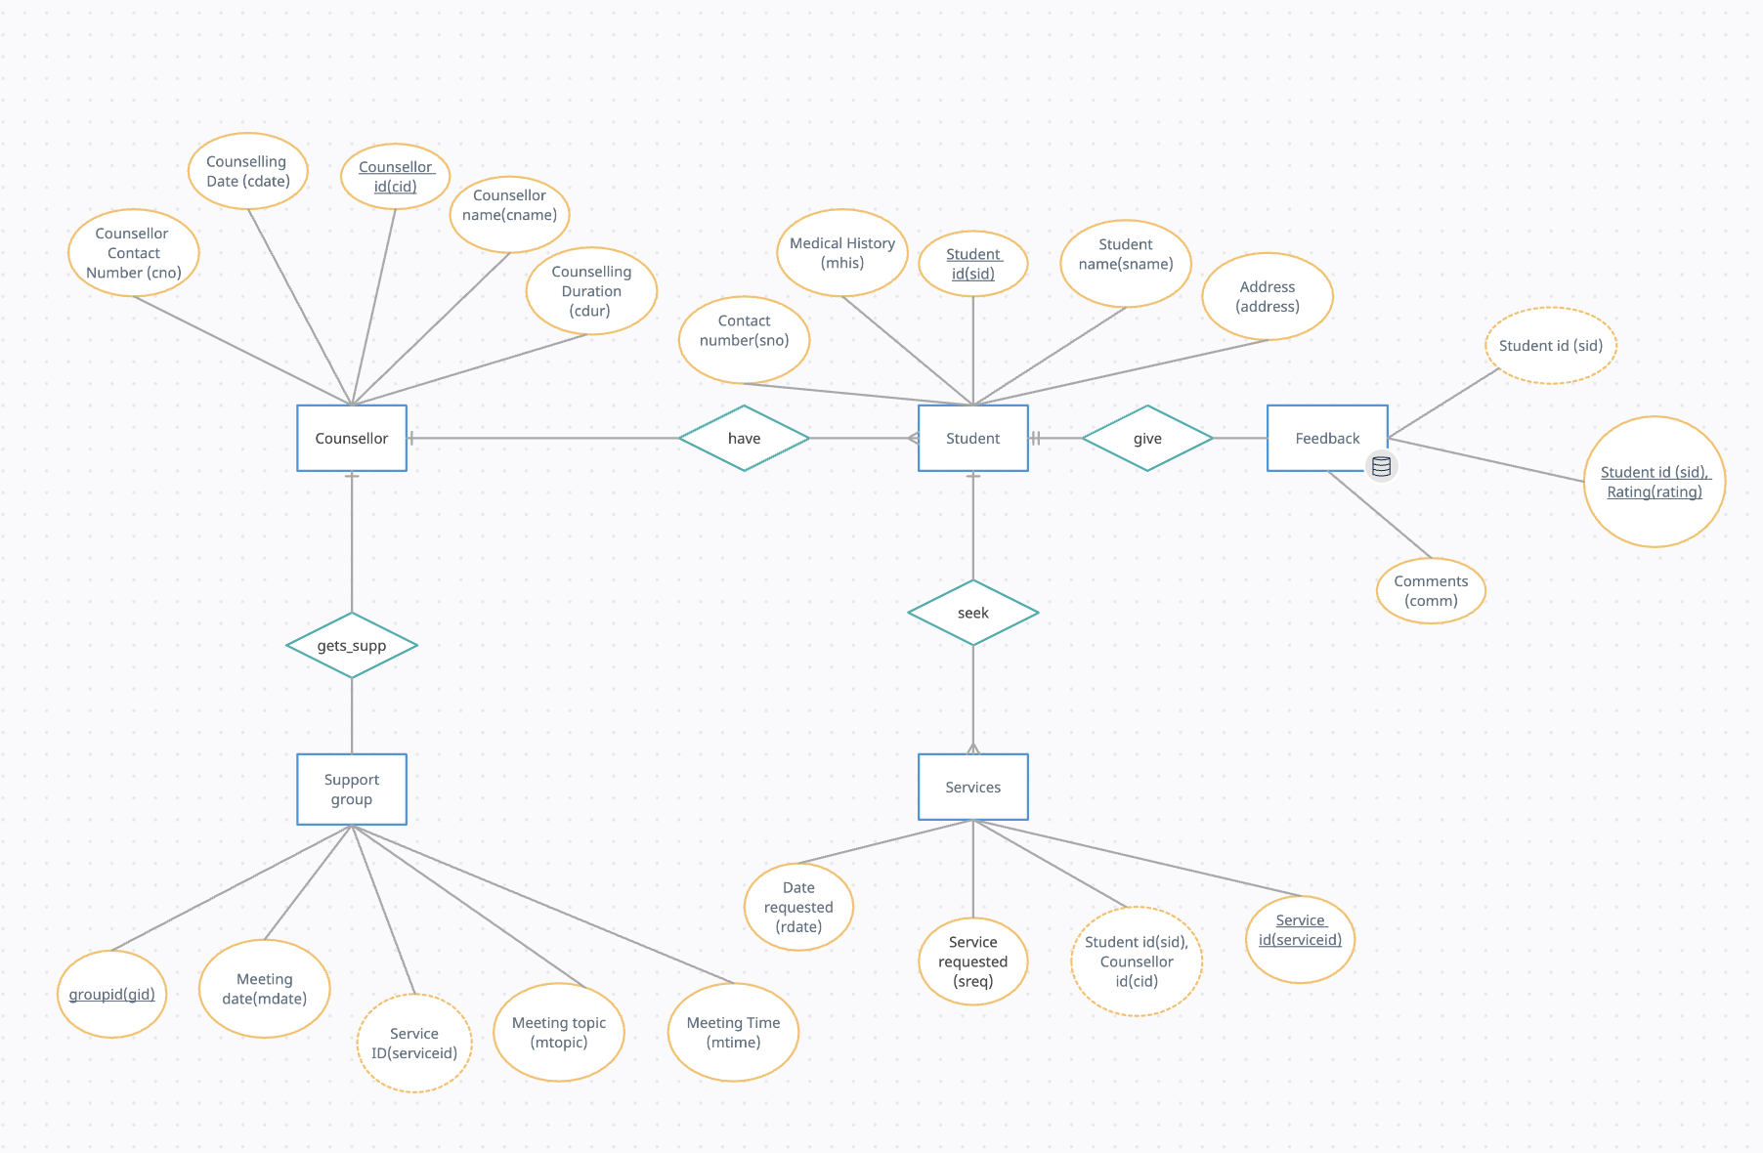

**DDL COMMANDS**

SQL> create table students(

2 sname varchar2(20),

3 sid varchar2(15),

4 sconnum number(15),

5 saddress varchar2(30),

6 mhist varchar2(40),

7 CONSTRAINT pkey_sid PRIMARY KEY (sid));

Table created.

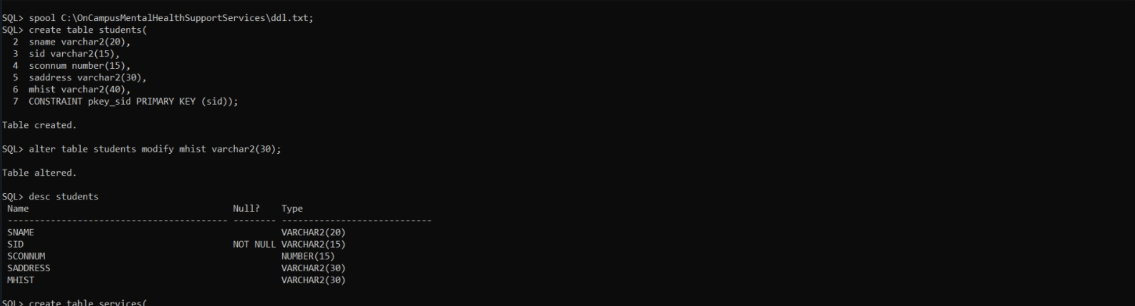

SQL> create table services(

2 sid varchar2(15),

3 cid varchar2(15),

4 serviceid varchar2(20),

5 rdate date,

6 statusreq varchar2(20),

7 CONSTRAINT fkey_sid FOREIGN KEY (sid) REFERENCES students (sid) ON DELETE CASCADE,

8 CONSTRAINT pkey_serviceid PRIMARY KEY (serviceid));

Table created.

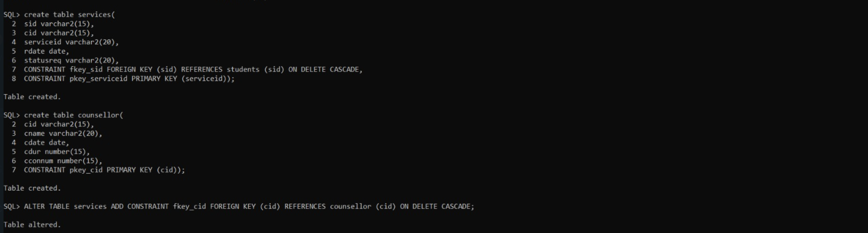

SQL> create table counsellor(

2 cid varchar2(15),

3 cname varchar2(20),

4 cdate date,

5 cdur number(15),

6 cconnum number(15),

7 CONSTRAINT pkey_cid PRIMARY KEY (cid));

Table created.

SQL> ALTER TABLE services ADD CONSTRAINT fkey_cid FOREIGN KEY (cid) REFERENCES counsellor (cid) ON DELETE CASCADE;

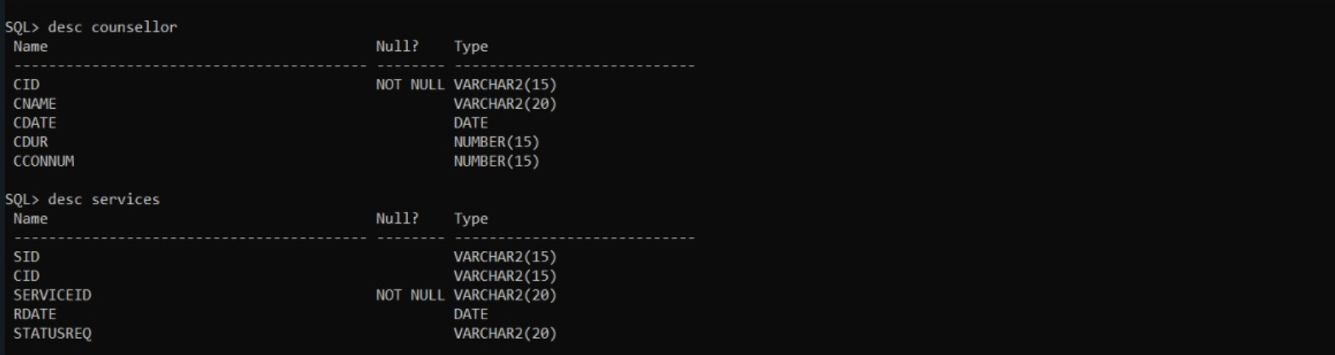

SQL> create table supportgroup(

2 gid varchar2(15),

3 serviceid varchar2(20),

4 mdate date,

5 mtime number(15),

6 mtopic varchar2(30),

7 CONSTRAINT pkey_gid PRIMARY KEY (gid),

8 CONSTRAINT fkey_serviceid FOREIGN KEY (serviceid) REFERENCES services (serviceid) ON DELETE CASCADE);

Table created.

SQL> desc supportgroup

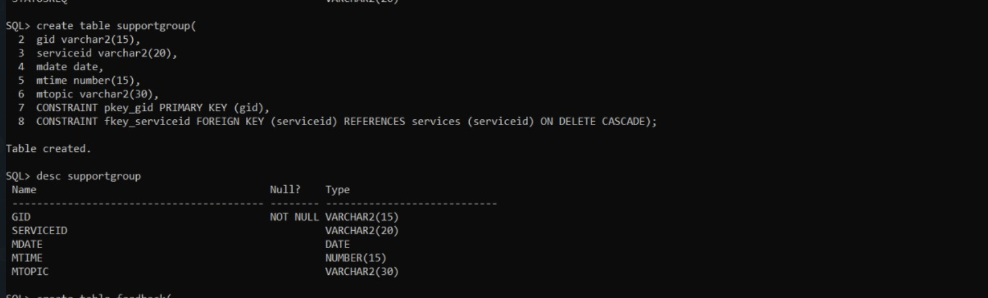

SQL> create table feedback(

2 sid varchar2(15),

3 rating number(10),

4 comments varchar2(20),

5 CONSTRAINT fkey_sidd FOREIGN KEY (sid) REFERENCES students (sid) ON DELETE CASCADE,

6 CONSTRAINT pkey_sid_rating PRIMARY KEY (sid,rating));

Table created.

SQL> desc feedback

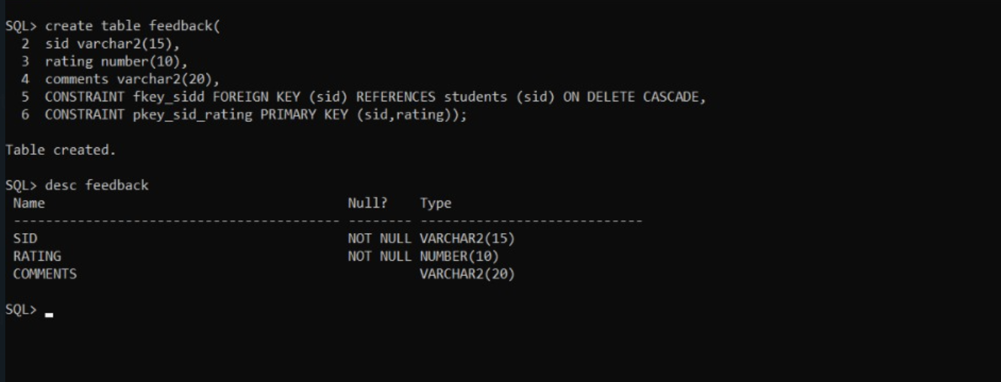

**DML COMMANDS**

SQL> insert into students values('&sname','&sid',&sconnum,'&saddress','&mhist');

Enter value for sname: Shruthi

Enter value for sid: 1602-21-737-052

Enter value for sconnum: 9293942413

Enter value for saddress: lbnagar

Enter value for mhist: nill

old 1: insert into students values('&sname','&sid',&sconnum,'&saddress','&mhist')

new 1: insert into students values('Shruthi','1602-21-737-052',9293942413,'lbnagar','nill')

1 row created.

SQL> /

Enter value for sname: Anurag

Enter value for sid: 1602-21-737-064

Enter value for sconnum: 876543210

Enter value for saddress: kothapet

Enter value for mhist: stress

old 1: insert into students values('&sname','&sid',&sconnum,'&saddress','&mhist')

new 1: insert into students values('Anurag','1602-21-737-064',876543210,'kothapet','stress')

1 row created.

SQL> /

Enter value for sname: shriya

Enter value for sid: 1602-21-737-051

Enter value for sconnum: 7231564724

Enter value for saddress: suncity

Enter value for mhist: anxiety

old 1: insert into students values('&sname','&sid',&sconnum,'&saddress','&mhist')

new 1: insert into students values('shriya','1602-21-737-051',7231564724,'suncity','anxiety')

1 row created.

SQL> /

Enter value for sname: prudhvi

Enter value for sid: 1602-21-737-040

Enter value for sconnum: 6789435261

Enter value for saddress: jntu

Enter value for mhist: low bp

old 1: insert into students values('&sname','&sid',&sconnum,'&saddress','&mhist')

new 1: insert into students values('prudhvi','1602-21-737-040',6789435261,'jntu','low bp')

1 row created.

SQL> /

Enter value for sname: anish

Enter value for sid: 1602-21-737-008

Enter value for sconnum: 9099897653

Enter value for saddress: koti

Enter value for mhist: high bp

old 1: insert into students values('&sname','&sid',&sconnum,'&saddress','&mhist')

new 1: insert into students values('anish','1602-21-737-008',9099897653,'koti','high bp')

1 row created.

SQL> /

Enter value for sname: vanshika

Enter value for sid: 1602-21-737-060

Enter value for sconnum: 9876008765

Enter value for saddress: sharath mall

Enter value for mhist: short tempered

old 1: insert into students values('&sname','&sid',&sconnum,'&saddress','&mhist')

new 1: insert into students values('vanshika','1602-21-737-060',9876008765,'sharath mall','short tempered')

1 row created.

SQL> /

Enter value for sname: deepthi

Enter value for sid: 1602-21-737-015

Enter value for sconnum: 9695438910

Enter value for saddress: malakpet

Enter value for mhist: underweight

old 1: insert into students values('&sname','&sid',&sconnum,'&saddress','&mhist')

new 1: insert into students values('deepthi','1602-21-737-015',9695438910,'malakpet','underweight')

1 row created.

SQL> select * from students;

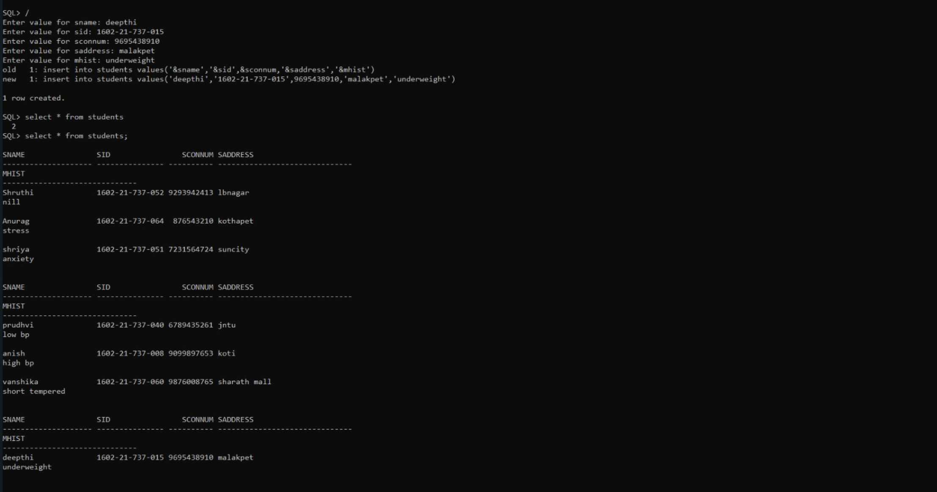

SQL> insert into counsellor values('&cname','&cid','&cdate',&condur,&cconnum);

Enter value for cname: a

Enter value for cid: 1

Enter value for cdate: 01-APR-2023

Enter value for condur: 30

Enter value for cconnum: 1234567890

old 1: insert into counsellor values('&cname','&cid','&cdate',&condur,&cconnum)

new 1: insert into counsellor values('a','1','01-APR-2023',30,1234567890)

1 row created.

SQL> /

Enter value for cname: b

Enter value for cid: 2

Enter value for cdate: 12-APR-2023

Enter value for condur: 45

Enter value for cconnum: 9293949589

old 1: insert into counsellor values('&cname','&cid','&cdate',&condur,&cconnum)

new 1: insert into counsellor values('b','2','12-APR-2023',45,9293949589)

1 row created.

SQL> /

Enter value for cname: c

Enter value for cid: 3

Enter value for cdate: 14-MAR-2023

Enter value for condur: 50

Enter value for cconnum: 9989765430

old 1: insert into counsellor values('&cname','&cid','&cdate',&condur,&cconnum)

new 1: insert into counsellor values('c','3','14-MAR-2023',50,9989765430)

1 row created.

SQL> /

Enter value for cname: d

Enter value for cid: 4

Enter value for cdate: 20-MAY-2023

Enter value for condur: 60

Enter value for cconnum: 9765487630

old 1: insert into counsellor values('&cname','&cid','&cdate',&condur,&cconnum)

new 1: insert into counsellor values('d','4','20-MAY-2023',60,9765487630)

1 row created.

SQL> /

Enter value for cname: e

Enter value for cid: 5

Enter value for cdate: 31-MAY-2023

Enter value for condur: 25

Enter value for cconnum: 9692587650

old 1: insert into counsellor values('&cname','&cid','&cdate',&condur,&cconnum)

new 1: insert into counsellor values('e','5','31-MAY-2023',25,9692587650)

1 row created.

SQL> /

Enter value for cname: f

Enter value for cid: 6

Enter value for cdate: 12-MAY-2023

Enter value for condur: 55

Enter value for cconnum: 9876098760

old 1: insert into counsellor values('&cname','&cid','&cdate',&condur,&cconnum)

new 1: insert into counsellor values('f','6','12-MAY-2023',55,9876098760)

1 row created.

SQL> select * from counsellor;

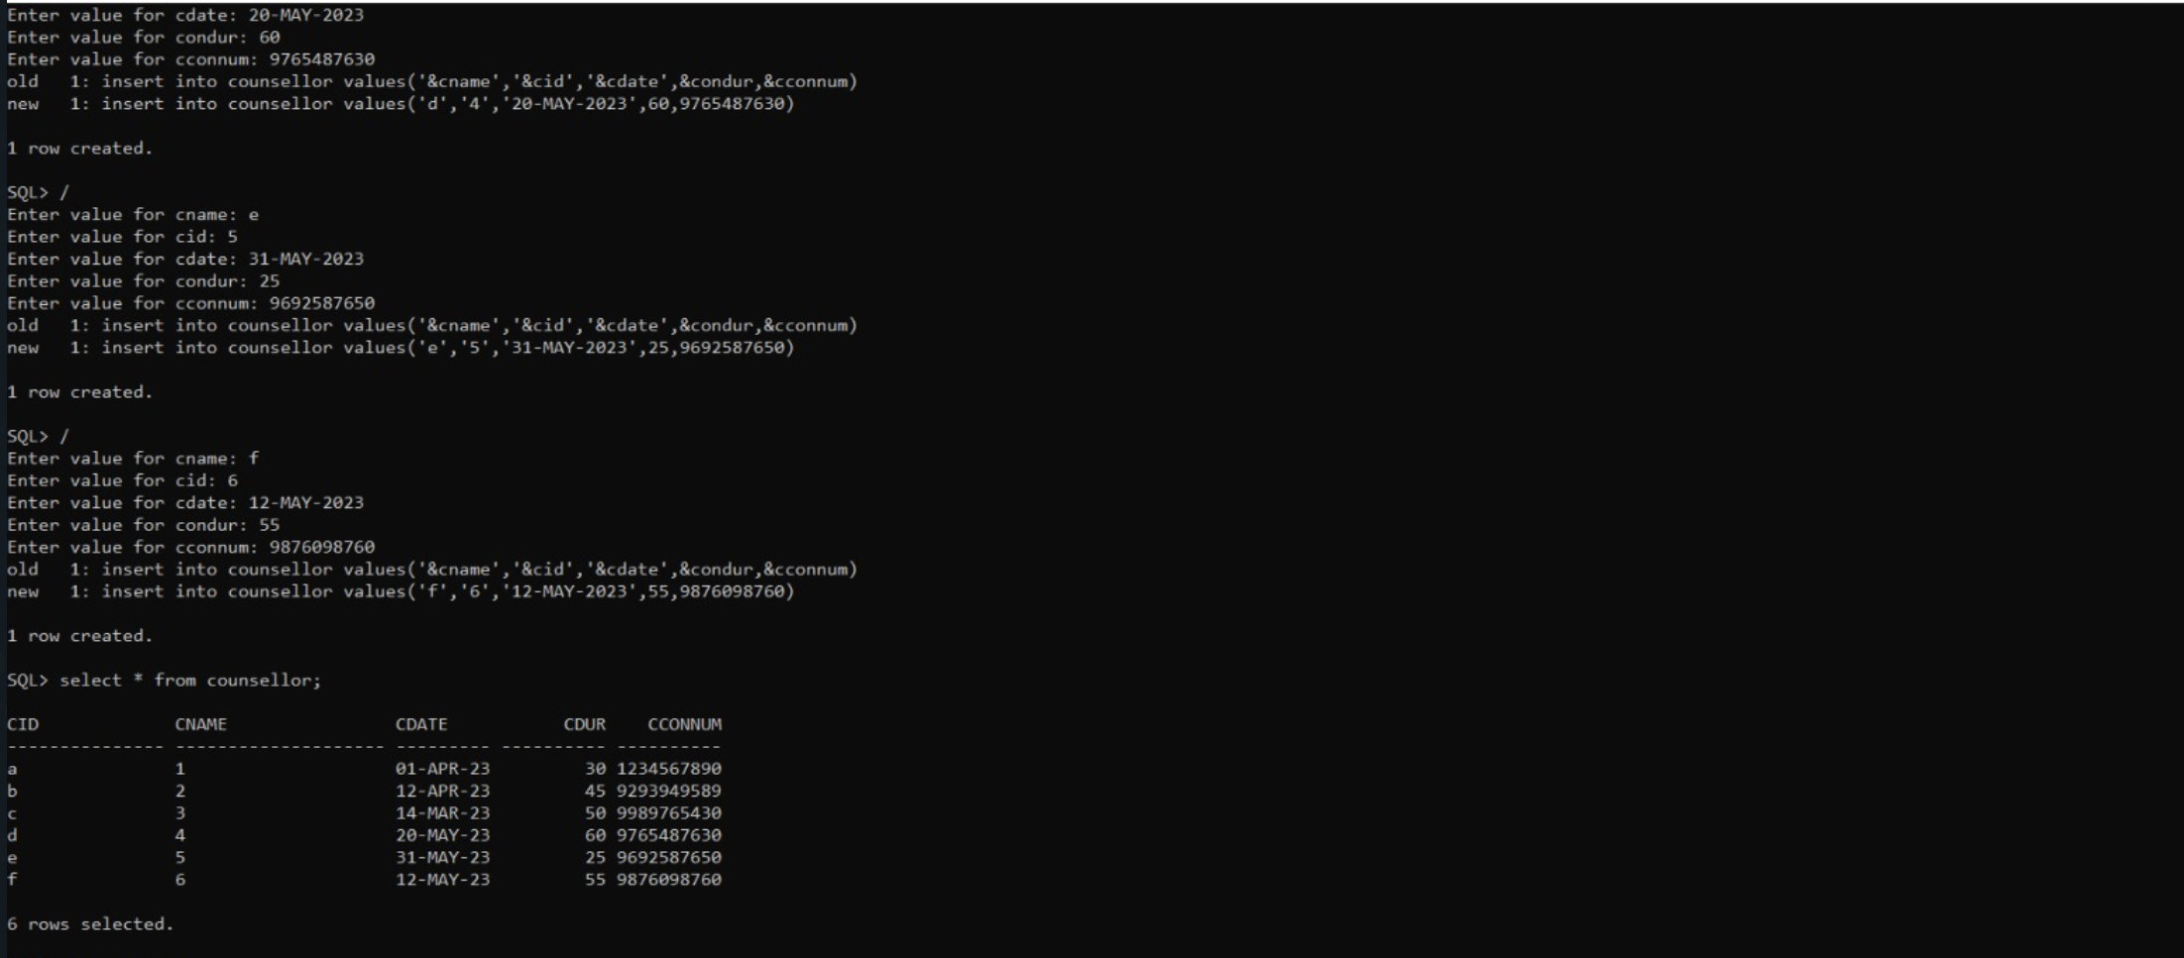

SQL> insert into services values('&sid','&cid','&serviceid','&rdate','&statusreq');

Enter value for sid: 1602-21-737-052

Enter value for cid: c

Enter value for serviceid: 20

Enter value for rdate: 21-APR-2023

Enter value for statusreq: completed

old 1: insert into services values('&sid','&cid','&serviceid','&rdate','&statusreq')

new 1: insert into services values('1602-21-737-052','c','20','21-APR-2023','completed')

1 row created.

SQL> /

Enter value for sid: 1602-21-737-064

Enter value for cid: b

Enter value for serviceid: 21

Enter value for rdate: 30-MAY-2023

Enter value for statusreq: pending

old 1: insert into services values('&sid','&cid','&serviceid','&rdate','&statusreq')

new 1: insert into services values('1602-21-737-064','b','21','30-MAY-2023','pending')

1 row created.

SQL> /

Enter value for sid: 1602-21-737-051

Enter value for cid: d

Enter value for serviceid: 22

Enter value for rdate: 21-MAY-2023

Enter value for statusreq: pending

old 1: insert into services values('&sid','&cid','&serviceid','&rdate','&statusreq')

new 1: insert into services values('1602-21-737-051','d','22','21-MAY-2023','pending')

1 row created.

SQL> /

Enter value for sid: 1602-21-737-040

Enter value for cid: e

Enter value for serviceid: 23

Enter value for rdate: 30-APR-2023

Enter value for statusreq: completed

old 1: insert into services values('&sid','&cid','&serviceid','&rdate','&statusreq')

new 1: insert into services values('1602-21-737-040','e','23','30-APR-2023','completed')

1 row created.

SQL> /

Enter value for sid: 1602-21-737-008

Enter value for cid: f

Enter value for serviceid: 24

Enter value for rdate: 1-MAY-2023

Enter value for statusreq: pending

old 1: insert into services values('&sid','&cid','&serviceid','&rdate','&statusreq')

new 1: insert into services values('1602-21-737-008','f','24','1-MAY-2023','pending')

1 row created.

SQL> /

Enter value for sid: 1602-21-737-060

Enter value for cid: a

Enter value for serviceid: 25

Enter value for rdate: 22-JUN-2023

Enter value for statusreq: pending

old 1: insert into services values('&sid','&cid','&serviceid','&rdate','&statusreq')

new 1: insert into services values('1602-21-737-060','a','25','22-JUN-2023','pending')

1 row created.

SQL> /

Enter value for sid: 1602-21-737-015

Enter value for cid: d

Enter value for serviceid: 26

Enter value for rdate: 30-MAY-2023

Enter value for statusreq: pending

old 1: insert into services values('&sid','&cid','&serviceid','&rdate','&statusreq')

new 1: insert into services values('1602-21-737-015','d','26','30-MAY-2023','pending')

1 row created.

SQL> select * from services;

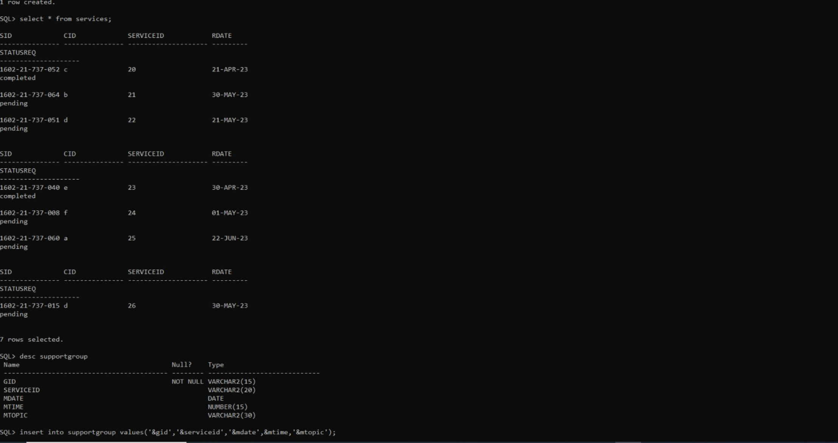

SQL> insert into supportgroup values('&gid','&serviceid','&mdate',&mtime,'&mtopic');

Enter value for gid: 001

Enter value for serviceid: 20

Enter value for mdate: 21-APR-2023

Enter value for mtime: 3

Enter value for mtopic: Sadness and demotivating

old 1: insert into supportgroup values('&gid','&serviceid','&mdate',&mtime,'&mtopic')

new 1: insert into supportgroup values('001','20','21-APR-2023',3,'Sadness and demotivating')

1 row created.

SQL> /

Enter value for gid: 002

Enter value for serviceid: 21

Enter value for mdate: 30-MAY-23

Enter value for mtime: 4

Enter value for mtopic: Stressed

old 1: insert into supportgroup values('&gid','&serviceid','&mdate',&mtime,'&mtopic')

new 1: insert into supportgroup values('002','21','30-MAY-23',4,'Stressed')

1 row created.

SQL> /

Enter value for gid: 003

Enter value for serviceid: 22

Enter value for mdate: 21-MAY-2023

Enter value for mtime: 10

Enter value for mtopic: anxiety

old 1: insert into supportgroup values('&gid','&serviceid','&mdate',&mtime,'&mtopic')

new 1: insert into supportgroup values('003','22','21-MAY-2023',10,'anxiety')

1 row created.

SQL> /

Enter value for gid: 004

Enter value for serviceid: 23

Enter value for mdate: 30-APR-2023

Enter value for mtime: 12

Enter value for mtopic: Fails to concentrate

old 1: insert into supportgroup values('&gid','&serviceid','&mdate',&mtime,'&mtopic')

new 1: insert into supportgroup values('004','23','30-APR-2023',12,'Fails to concentrate')

1 row created.

SQL> /

Enter value for gid: 005

Enter value for serviceid: 24

Enter value for mdate: 01-MAY-2023

Enter value for mtime: 1

Enter value for mtopic: Demotivated

old 1: insert into supportgroup values('&gid','&serviceid','&mdate',&mtime,'&mtopic')

new 1: insert into supportgroup values('005','24','01-MAY-2023',1,'Demotivated')

1 row created.

SQL> /

Enter value for gid: 006

Enter value for serviceid: 25

Enter value for mdate: 22-JUN-2023

Enter value for mtime: 2

Enter value for mtopic: Short tempered

old 1: insert into supportgroup values('&gid','&serviceid','&mdate',&mtime,'&mtopic')

new 1: insert into supportgroup values('006','25','22-JUN-2023',2,'Short tempered')

1 row created.

SQL> /

Enter value for gid: 007

Enter value for serviceid: 26

Enter value for mdate: 30-MAY-2023

Enter value for mtime: 4

Enter value for mtopic: Introvert behaviour

old 1: insert into supportgroup values('&gid','&serviceid','&mdate',&mtime,'&mtopic')

new 1: insert into supportgroup values('007','26','30-MAY-2023',4,'Introvert behaviour')

1 row created.

SQL> select * from supportgroup;

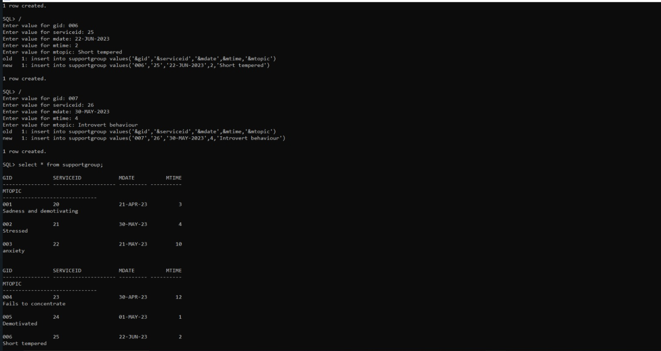

SQL> insert into feedback values('&sid',&rating,'&comments');

Enter value for sid: 1602-21-737-052

Enter value for rating: 4

Enter value for comments: good

old 1: insert into feedback values('&sid',&rating,'&comments')

new 1: insert into feedback values('1602-21-737-052',4,'good')

1 row created.

SQL> /

Enter value for sid: 1602-21-737-064

Enter value for rating: 3

Enter value for comments: can be improved

old 1: insert into feedback values('&sid',&rating,'&comments')

new 1: insert into feedback values('1602-21-737-064',3,'can be improved')

1 row created.

SQL> /

Enter value for sid: 1602-21-737-051

Enter value for rating: 3.5

Enter value for comments: satisfactory

old 1: insert into feedback values('&sid',&rating,'&comments')

new 1: insert into feedback values('1602-21-737-051',3.5,'satisfactory')

1 row created.

SQL> /

Enter value for sid: 1602-21-737-040

Enter value for rating: 2.5

Enter value for comments: not satisfied

old 1: insert into feedback values('&sid',&rating,'&comments')

new 1: insert into feedback values('1602-21-737-040',2.5,'not satisfied')

1 row created.

SQL> /

Enter value for sid: 1602-21-737-008

Enter value for rating: 3

Enter value for comments: ok

old 1: insert into feedback values('&sid',&rating,'&comments')

new 1: insert into feedback values('1602-21-737-008',3,'ok')

1 row created.

SQL> /

Enter value for sid: 1602-21-737-060

Enter value for rating: 4

Enter value for comments: better

old 1: insert into feedback values('&sid',&rating,'&comments')

new 1: insert into feedback values('1602-21-737-060',4,'better')

1 row created.

SQL> /

Enter value for sid: 1602-21-737-015

Enter value for rating: 4.5

Enter value for comments: very good

old 1: insert into feedback values('&sid',&rating,'&comments')

new 1: insert into feedback values('1602-21-737-015',4.5,'very good')

1 row created.

SQL> select * from feedback;

